AVL Trees:

Introduction:
A binary search tree (BST) is a data structure which, on average, provides O(Log(n)) for insertions, deletion and searching, but this is not the worst-case scenario. BST have a significant flaw in that they are entirely dependent on the insertion order of the data. When a binary tree is unbalanced, its performance is affected and can result in a worst-case scenario of O(n) for various operations. This research paper investigates the data structure of an AVL tree an AVL is a self-balancing tree that corrects for a binary tree’s worst-case scenario. To understand the effectiveness of this algorithm, our research will be discussed in four sections:
- AVL Algorithm: A general discussion of the core concepts behind the algorithm and its practical implementations.
- Implementation: A discussion of the reports code base and the design decisions behind the data structures implementation.
- Theoretical Analysis: Analyzing Big(O) for insertion, deletion, and searching, and proving correctness.
- Empirical Analysis: analyzing the runtime through the use of an experiment.

AVL Algorithm:
In 1962 a pair of Soviet mathematicians, Georgy Adelson-Velsky and Evgenii Landis, sought to create a data structure which guaranteed $O(\log(n))$ performance for deletion, search and insertion[1]. To reach this goal, they needed a tree which was as dense as possible. This idea of a dense tree is what can be referred to as a balanced tree. A balanced tree is a tree whose height at the root node is no larger than $log(n)$ [3]. When we have this property, a BST is guaranteed to achieve $O(\log(n))$ performance, but a traditional BST is not guaranteed to be balanced. To solve this issue, our Soviet mathematicians created the AVL tree which is a self-balancing tree.
Today, the AVL Tree has several use cases and has a rich history of practical application. For example, Linux before 2.4.10 used AVL trees for tracking virtual memory areas. Linux also used AVL trees for its peer cache tracking system. Generally, you’ll most often find AVL trees used in system operating kernels, and other system software. AVL trees are foundational to computer science because they have characteristics that are both practical and useful. In particular, this data structure should be used if insertion often occurs in sorted order, and if retrieval and deletion is random [4]. To gain an understanding of an AVL tree, We will first discuss how it identifies and tracks and balance and then discuss how it fixes imbalance.

Identifying Imbalance
Figure 1:
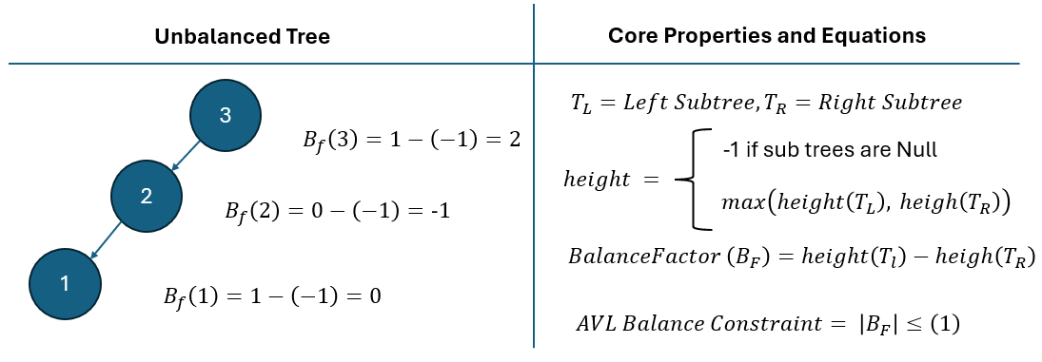
Figure one outlines some fundamental properties of an AVL tree. Each node in an AVL tree stores its height or simply put the length of the largest path beneath it. As shown in Figure 1, the height of a node is then used to calculate its balance factor ($B_F$). An AVL tree ensures that each node has a $|B_F| \le 1$. When each node is constrained to this property, we are guaranteed to have a balanced tree which we will show prove in later sections. To maintain the property of $|B_F| \le 1$, an AVL tree performs left, right, left-right, right-left rotations.

Left and Right Rotations
Figure 2
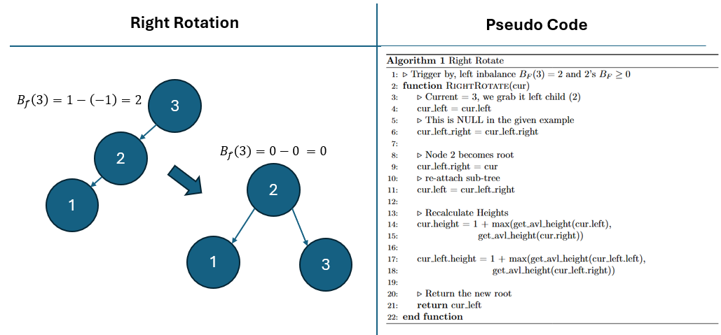
Figure Two outlines the process for right rotation. Although left and right rotations are different from one another, their core logic is just simply reversed and therefore we’ll just cover a right rotation. For an example of a left rotation please see the appendix (cite).
A right rotation is triggered by a left imbalance in the tree. Looking at the diagram above, we find that Node 3 has a $B_F \gte 1$ and Node 2 has a $B_F \gte 0$. Under these conditions, we trigger the process of a right rotation. The Pseudo code in the diagram walks through this process step-by-step, but simply put, Node 2 becomes the new root node in this process with node 3 being reassigned as its right child.
Left-Right and Right-Left Rotation:
Figure 3
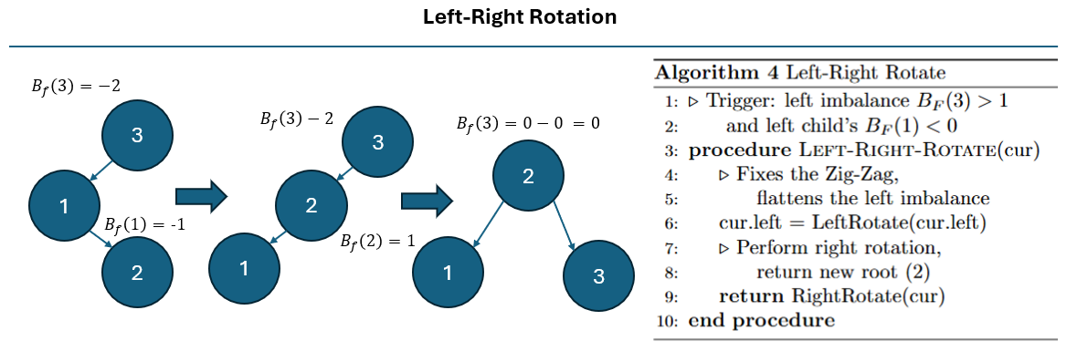
When we have an imbalance that has a zigzag pattern, we perform either a left-right or a right-left rotation. The diagram above outlines a left -right rotation, and in the appendix, you’ll find similar logic for a right-left rotation (CITE). A left right rotation is triggered by two conditions: condition one, the current node has a $B_F>1$; and condition 2, the current node’s left child has a $B_F>1$. To fix this imbalance we perform steps. The first step flattens out the zigzag by performing a left rotation. The second step we correct for the observed imbalances by performing a right rotation.

Theoretical Analysis:

Appendix

Left Rotation
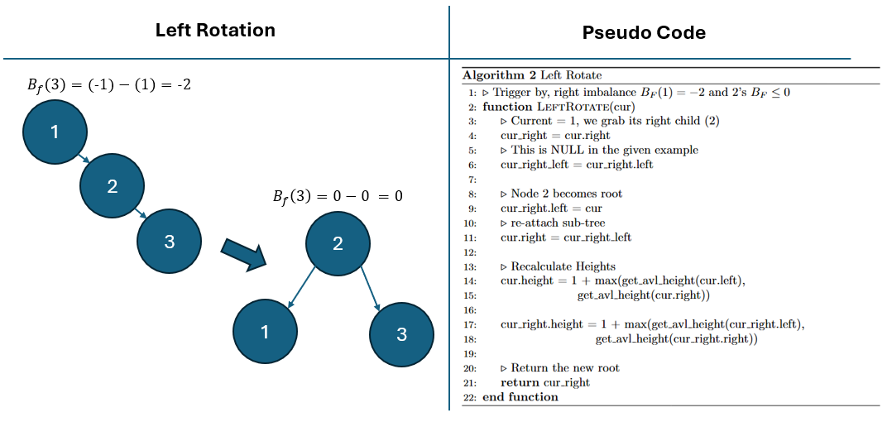

Right-Left Rotation
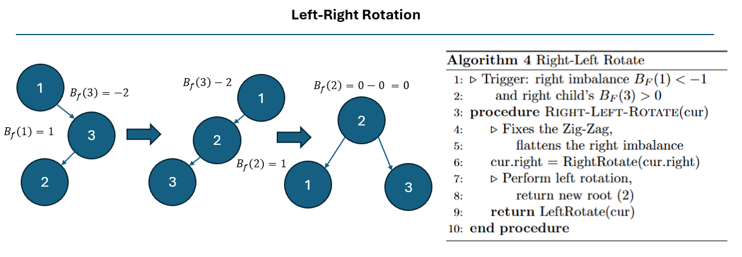

Sources:
- https://www.cs.rochester.edu/~hbeadle/csc162/_static/lectures/ds_history.pdf
- https://www.cs.umd.edu/class/fall2021/cmsc132-030X/labs/Week15/AdvancedTrees.pdf
- Balanced Binary Tree - GeeksforGeeks
- https://benpfaff.org/papers/libavl.pdf

Theoretical Analysis:

Experimental Design

Empirical Analysis

Conclusion:

References:

